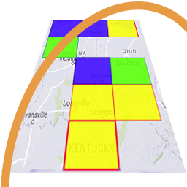
GridTracker v1.21.1212
An Amateur Radio Companion

Dec 12th, 2021

General Information

This is the last release of 2021 and includes an overhaul of the Call Roster code so that additional fixes and improvements can be more easily made in early 2022. Additionally this version may see some slight performance improvements when the Call Roster has a lot of decodes to display.

Program Update
[Enhancements]
- Change how uncertain counties are displayed in the call roster using ? Symbols instead of ~. Also improve the hover over tool-tip when hovering over those entries instructing the user to click to do a lookup to show the county listed in the lookup service.
- Call Roster code refactored for performance and to make future improvments and fixes easier.

GridTracker is:
Copyright © 1998-2020 by Stephen ‘Tag’ Loomis
Copyright © 2020-2022 by GridTracker.org
All rights reserved.

GridTracker uses the OSS compliant BSD 3 Clause License
Source code is available at GitLab: https://gitlab.com/gridtracker.org/gridtracker

